# Cloud Computing Workshop with AWS

## Detailed Project / Product Document

### Project Information

Project Name:  
Supermarket Path Planner  
  
Student Names:  
Guy Sofer, Alicia Belhassen, Ben Hanover

This document will fully describe the project content (10-30 pages).

Submission date: Feb 1, 2025.

The below are mandatory details to the document. Feel free to add any additional information as you like.

### 1. Introduction

**Provide an up-to-date summary and fine-tuning of the content outlined in the proposal document. This includes discussing the project's Motivation, Context, Objectives, and how it stands in terms of Innovation compared to existing market products.**

The Supermarket Path Planner addresses a prevalent challenge in modern retail: navigating large supermarket layouts efficiently. Traditional aisle signage often fails to provide the specificity customers need to locate items quickly, leading to frustration, wasted time, and inefficiencies. This issue is compounded by frequent layout changes in supermarkets, which are rarely communicated to customers in real time.

The project's primary objective is to create an integrated, cloud-based solution leveraging AWS services. It consists of a mobile app for customers to input grocery lists and receive optimized shopping routes and a web platform for store owners to manage and update layouts dynamically. By combining intelligent pathfinding algorithms with real-time layout updates, the platform offers a seamless shopping experience for customers while empowering store owners with tools to enhance store management.

Compared to existing solutions, the Supermarket Path Planner stands out due to its innovative features. Unlike static store maps or online grocery delivery platforms, it provides dynamic, personalized navigation tailored to individual shopping lists. Additionally, its cross-store usability and scalable cloud-based architecture ensure consistent, real-time functionality across multiple grocery chains. These features position the project as a transformative tool in the retail sector, enhancing customer satisfaction and operational efficiency.

### 2. System Main components

**Describe the system’s main components comprehensively. This section should offer a detailed overview of the primary components constituting your system. Utilize diagrams such as squares and arrows to depict their relationships. Various tools like Lucidchart or Draw.io can aid in creating these diagrams.**

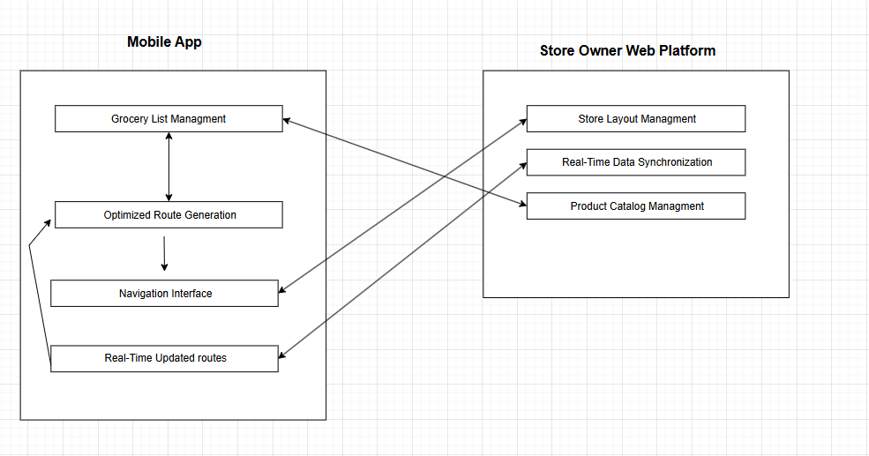

**1. Customer Mobile App**

* **Grocery List Management**: Enables customers to create, edit, and save grocery lists. Past lists can be reused for convenience.
* **Optimized Route Generation**: Uses pathfinding algorithms (e.g., BFS, DFS, Dijkstra) to calculate the most efficient shopping route based on the grocery list and current store layout.
* **Interactive Navigation Interface**: Provides step-by-step guidance, including a visual map and textual directions, to navigate through the store.
* **Real-Time Updates**: Synchronizes with the backend to reflect any store layout changes or updates.

**2. Store Owner Web Platform**

* **Store Layout Management**: Allows store owners to update and manage product placements, aisle names, and overall store layouts dynamically.
* **Real-Time Data Synchronization**: Updates made on the platform are instantly reflected in the customer mobile app.
* **Product Catalog Management**: Enables the addition, removal, or modification of product information.
* **Analytics Dashboard** (Future Enhancement): Provides insights into customer navigation patterns and popular product searches.

### 3. System Architecture including AWS modules used per module

**Illustrate the system architecture encompassing servers, databases, storage, network, etc. Focus on each component's AWS module utilized in the project, elucidating the rationale behind the chosen modules. Additionally, discuss any third-party tools besides AWS and justify their selection. A diagram summarizing this architecture should be included.**

Ask help deciding on what to choose between managed services and self managed.

### 4. Data Base

**Explain the chosen database, rationale behind its selection, and provide a diagram showcasing tables, columns, and their relationships.**

Relational Database Schema

* Users Table:
  + user_id (Primary Key)
  + name
  + email
  + password_hash
  + preferences (JSON for non-critical user settings)
* Stores Table:
  + store_id (Primary Key)
  + store_name
  + location
  + layout (JSON or separate table for aisle mappings)
* Products Table:
  + product_id (Primary Key)
  + product_name
  + category
  + aisle
  + store_id (Foreign Key)
* ShoppingLists Table:
  + list_id (Primary Key)
  + user_id (Foreign Key)
  + created_at
  + list_data (JSON to store item IDs and quantities)
* NavigationRoutes Table (Optional for pre-computed routes):
  + route_id (Primary Key)
  + store_id (Foreign Key)
  + route_data (JSON for path details)

Non-Relational Database Schema (DynamoDB)

* Table: UserPreferences:
  + Partition Key: user_id
  + Attributes: preferences (JSON), last_updated
* Table: StoreLayouts:
  + Partition Key: store_id
  + Attributes: layout_data (JSON), last_updated

### 5. Flow charts

Present flow charts depicting the main operational flows of the system. Utilize diagrams for clarity and understanding.

### 6. Screen mockups

Create screen mockups for all primary screens of the system. Tools like PowerPoint, Canva, Photoshop, or Figma are suitable for this task.

### 7. Development tools

**Detail the development tools employed throughout the project, including Integrated Development Environments (IDEs), tools like GPT/CoPilot, etc.**

VS Code, Chat GPT, CoPilot

### 8. Submission Details

Include the GitHub link for the project repository.

### 9. Additional Notes

Feel free to add any supplementary information deemed relevant to the project.